Name: Gursimranpreet Kaur
Course: Android Application Development
Date: 3 nov 2025
Working model demo=
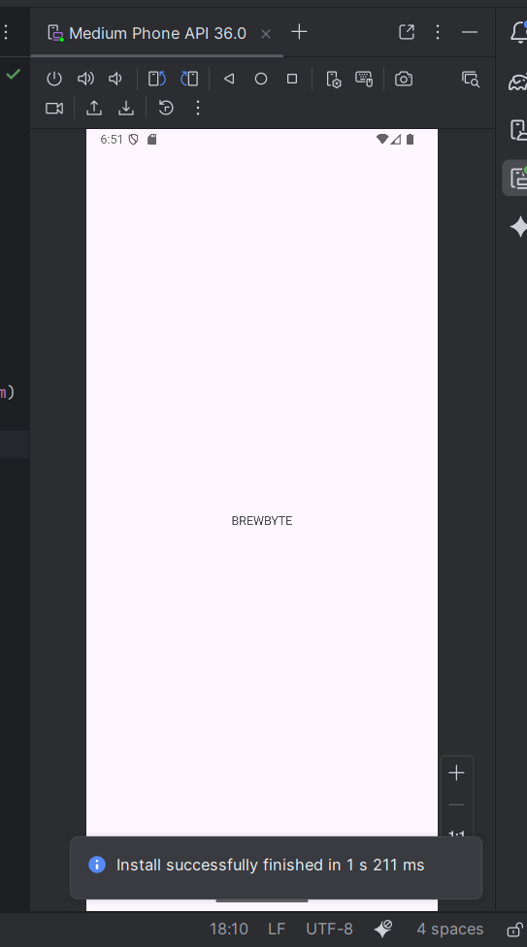
1.List of Collections

Collection Name | Description | Example Fields
Users | Stores user login details and profile info | userID, name, email, password, role
MenuItems | Contains all food and drink items available | itemID, name, category, price, imageURL
Orders | Tracks user orders | orderID, userID, items[], totalPrice, orderStatus, timestamp
Feedback | Optional collection for customer ratings | feedbackID, userID, rating, comment
Admin | Stores admin info for managing menu and orders | adminID, email, password

The following wireframes represent the user interface design of the BrewByte café ordering app. Each screen is designed with a simple and clean layout to make ordering food and drinks easy for users. The app also includes an admin side for café owners to manage menu items and orders efficiently.

Login System and Menu

